**Linux Administration**

**Assignment-1**

**Question-1:** Create a blank file named "myfile"

Ans:-

**Command:-TOUCH MYFILE**



**Question-2:** Open "myfile" in vi editor

Ans:

**Command:-** **VI MYFILE**

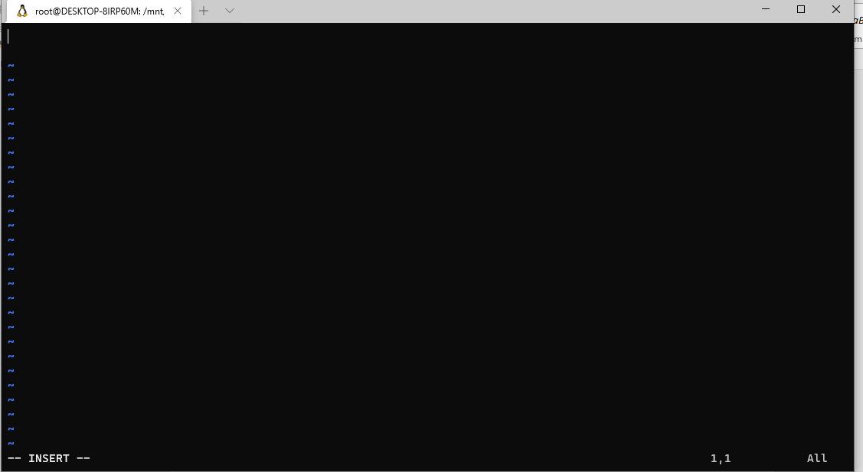

**Question-3**: Write your name, address, email id, phone number and blood group in 5 different lines

Ans:-

**Commands:- I 🡪** TO INSERT

**ESC🡪**TO EXIT FROM INSERT MODE

**:WQ🡪** TO WRITE AND QUIT

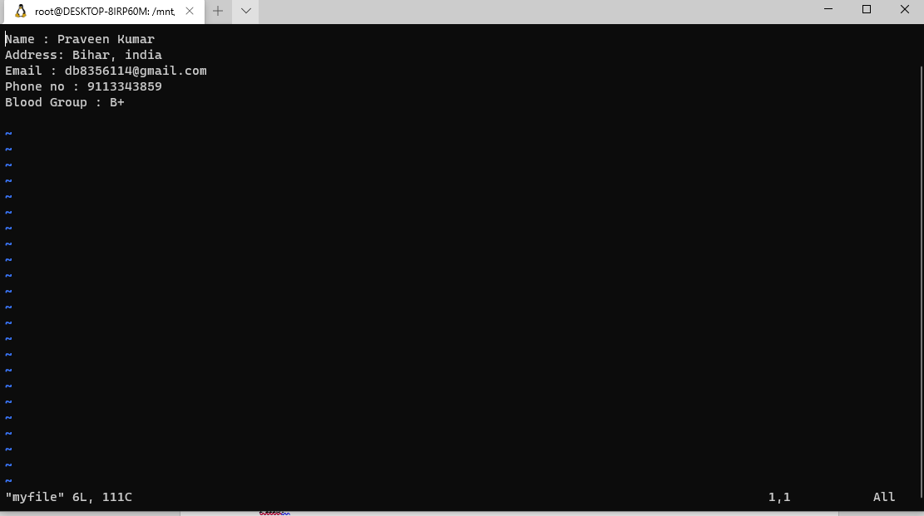

**Question-4:** Build one single expression to see the line with your name and blood group in myfile

Ans:-

**Command:-** GREP -E 'NAME|BLOOD' MYFILE

